**Your First Shell Program Part I, II, III**

  

**Before You Start**

* This exercise assumes that the user is working with the Ubuntu 18.04 distribution. If you are working with a different Linux distribution, the set of shell commands may vary from those available in Ubuntu 18.04.
* All commands and code discussed in this exercise will run in the Ubuntu console.
* Some steps are not explained in the tutorial**.** If you are not sure what to do:
  1. Consult the resources listed below and experiment in the Ubuntu console and try to solve the problem yourself. (The tutorial will provide reminders.)
  2. If you cannot solve the problem after a few tries, ask a TA for help.

**Learning Outcomes**

Student will be able to:

* Create a script file
* Modify file permissions
* Execute echo and printf commands
* Run a bash script

**Resources**

# Linux command line: bash + utilities

<https://ss64.com/bash/>

(You can use this reference to find descriptions of all the Bash commands that you will use in this and future hands-on exercises. It is recommended that you consult this reference frequently until you are familiar with frequently used commands.)

* Nano/Basics Guide

<https://wiki.gentoo.org/wiki/Nano/Basics_Guide>

**Part I: Bash Shell 1st Look:**

1. First clear your terminal by entering “clear” command.

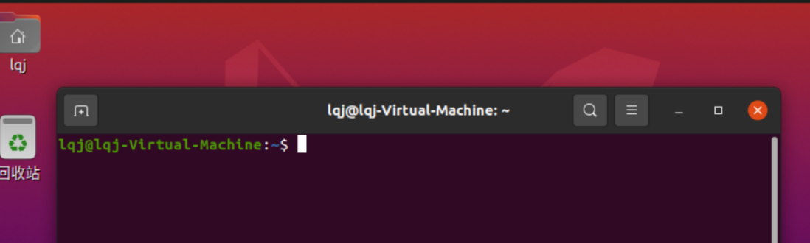

1. Check whether in your home directory, which you can find in a reserved environment variable $HOME.   
   >>> echo $HOME

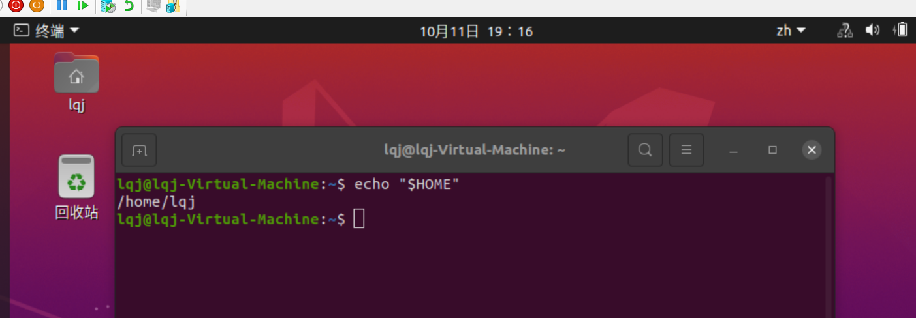

1. Find the current working directory with either the pwd command or the PWD variable:  
   >>>pwd  
   >>>echo “$PWD”

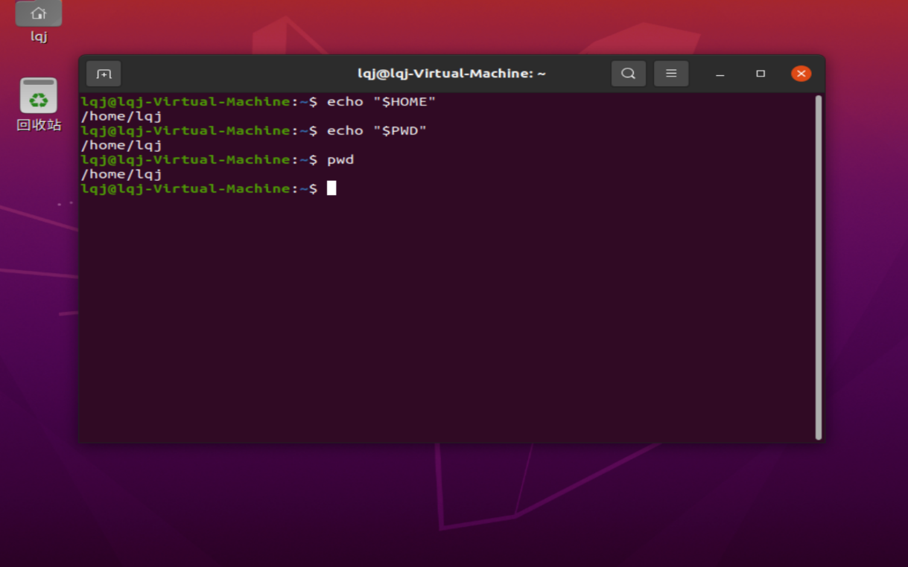

1. Clear your current screen. Then, move to the root directory.  
   Whenever you need, clear your screen.  
   >>>clear

>>> cd /  
>>> pwd

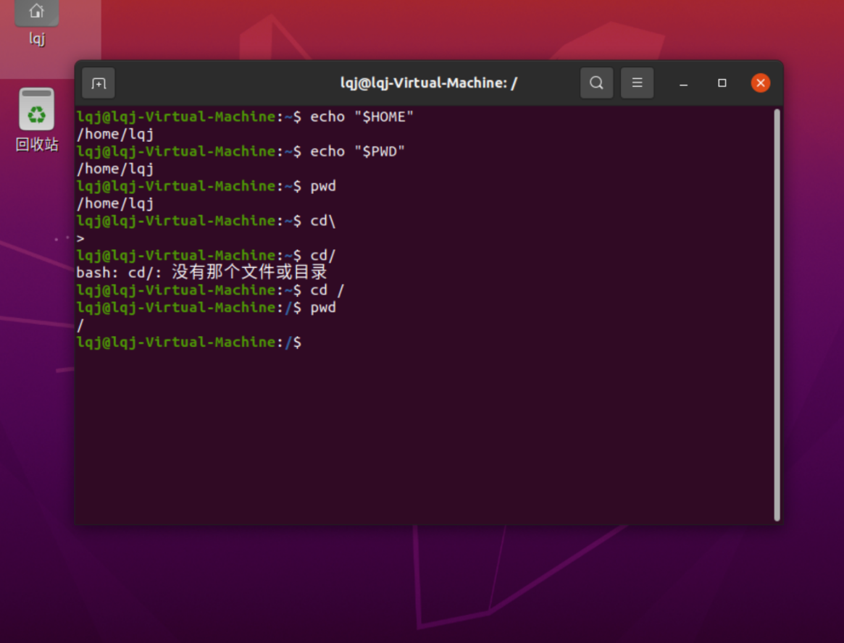

1. Move to your home directory back.  
   >>>cd  
   >>>pwd

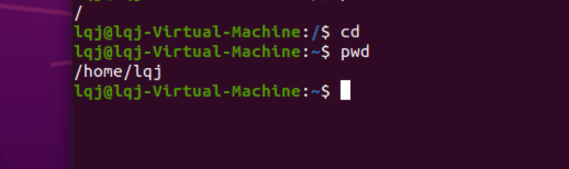

1. Check your bash version.  
   >>>bash --version

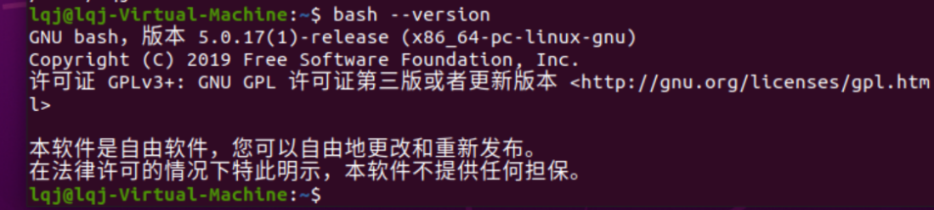

1. Write a Bash shell program that display “Hello, World!”  
   >>>echo Hello, World!

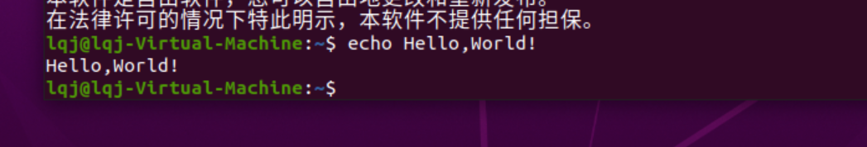

**Part II: Creating, saving, and running the first Bash Script**

1. Create your first script file by typing the following command in the console command line:

>>> echo echo Hello World! > HelloWorld.sh

Note: 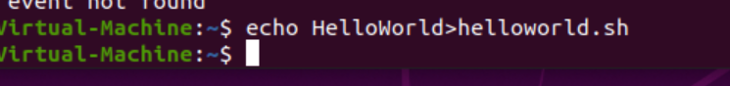

We are using the > to send the output of echo command to a file called HelloWorld.sh

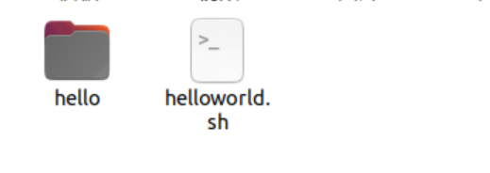

1. Run the script file by typing follow command:

>>> bash HelloWorld.sh

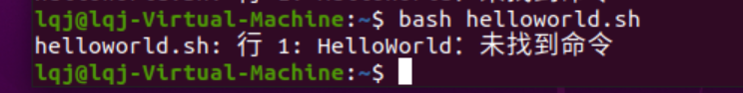

1. Add your directory to the path:

>>> export PATH=$PATH:~/

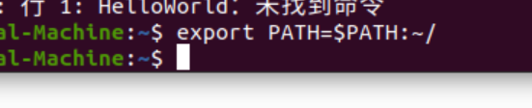

1. Give the execution permission to your file:

>>> chmod +x HelloWorld.sh

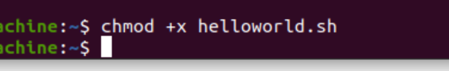

1. Now we can execute the file without typing the bash command:

>>> ./HelloWorld.sh

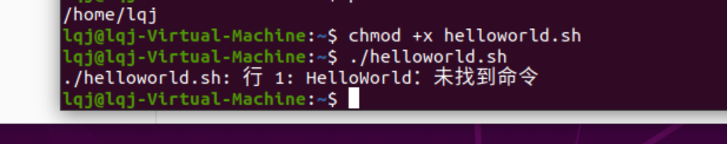

**Part III: Use nano to edit the file**

1. Type the following command to create a file with the nano editor:

>>> nano HelloWorld2.sh

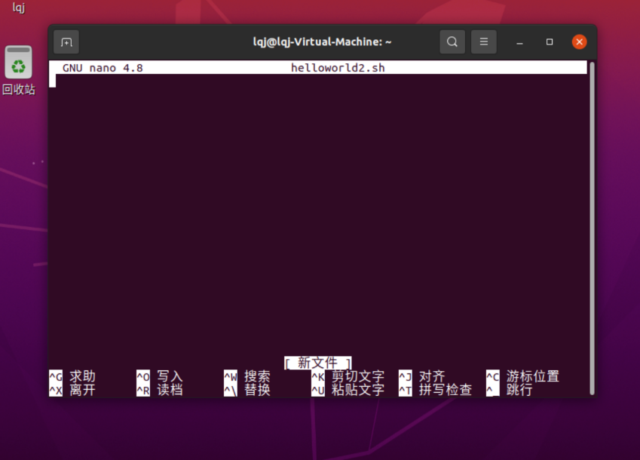

You should see an editor User Interface (UI) like this

1. Type the following commands in the editor:

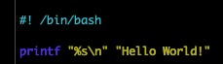

The first line is a shebang, which tells the shell what program to interpret the script with, when executed. In this example, the script is to be interpreted and run by the bash shell.

For the second line, the first part “%s\n” define how to print the text (%s means printing as string. \n means print a line break after the text)

The second part is the actual text that we want to print.

More format information can be found from <https://wiki-dev.bash-hackers.org/commands/builtin/printf>

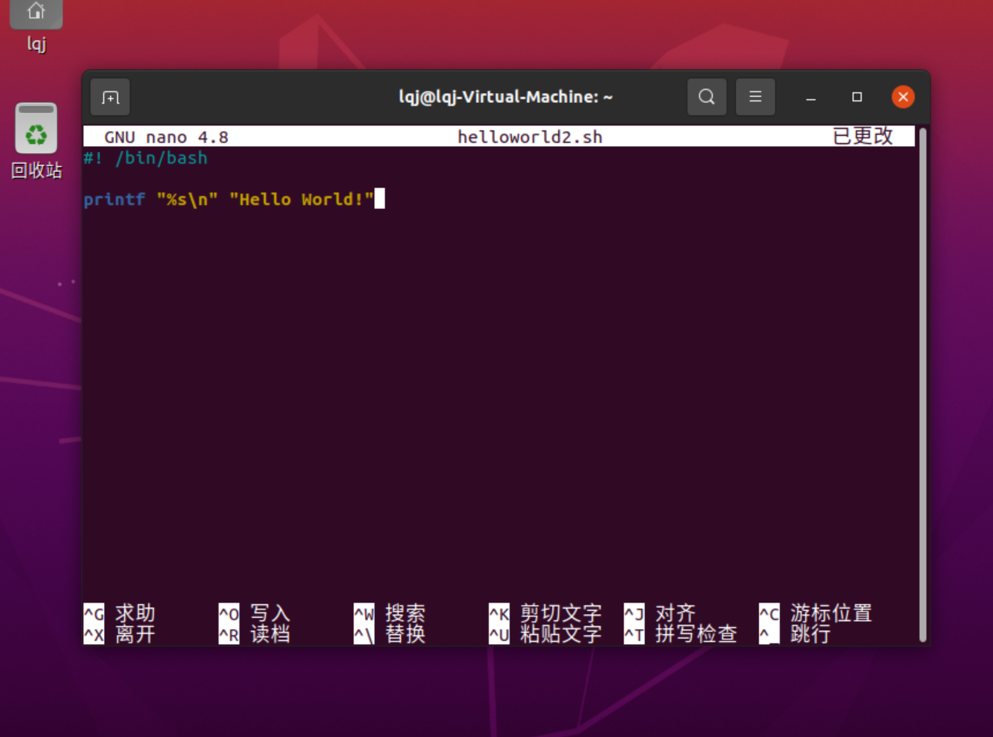

1. Hit the control + x key to quit the editor. You will see as below:



Then hit y key to confirm. The following message will appear as shown below:





After entering the enter key, the page flashes across and I could not catch the page.

1. Run the script by typing:

>>> bash HelloWorld2.sh

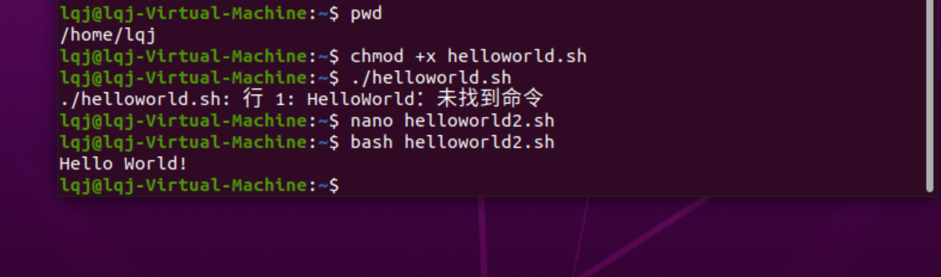

**Lab Assignment Submission Instructions:**

* *Capture screen shots of your practice session results and paste* ***into this document accordingly****.*
* *Add/Replace the “demo” screen shots seen in this document with your results.*
* *Please elaborate as needed.*
* **Submission:**

Please submit online. If that fails, email your results to: [bangpanliang@gmail.com](mailto:jcc4018@qq.com).

The subject of the email should be: [Your StudentID, Assignment Name]